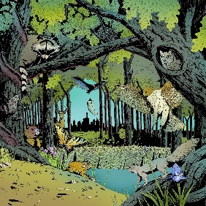
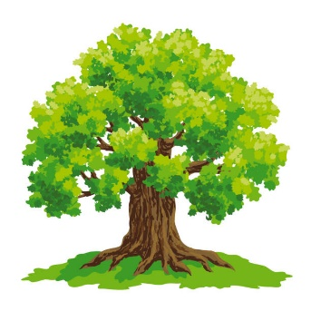
In the Forest

A few miles away there was a small forest, which was home to Mr and Mrs Red Squirrel and their five baby red squirrels, Mr and Mrs Robin, Mr and Mrs Rabbit and six babies and Mr and Mrs Fox and their four babies. At the edge of the forest there was a little cottage, inside lived a girl that had six cats Mr and Mrs Cat and four kittens. Next to the cottage was a tree, not just any tree, a tree home to the three greedy, selfish, big bad birds called Buzzard, the biggest, Kite about the same size and Kestrel the smallest. Everyday the cats would steal the mice from the big birds to eat and they did it in a very posh and clever style.

The birds know that the cats are stealing because they have a special place which is where the mice are, and they always count them. There is always a few missing in the morning and the cats are the only ones who knows where the mice are in the tree.

One dull day the cat family were stealing mice when suddenly a trap was around them and if they touched the wood trap they are dead! “What should we do Daddy?” said the smallest kitten.
Daddy replied, “Don’t worry my little ball of fluff, I have a plan.” Mr Cat explained,
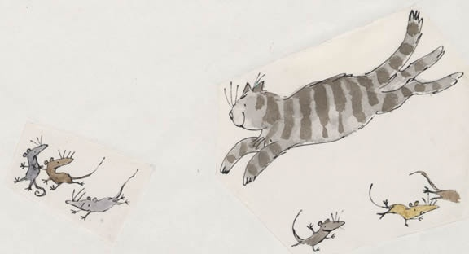
“Well if I can get the big birds to lift the trap you can get out and get back up.”
“But how are you going to convince the birds to lift the trap?” said the smallest cat.
“Just you wait and see!” said Daddy. So the next day the plan was in action.

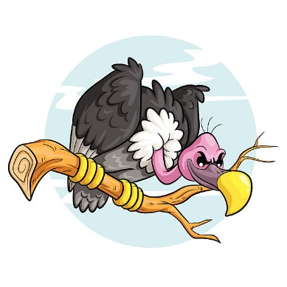
“Good morning Mr Big Bird Buzzard, Kitey Whatever,” said Mr Cat very politely. “I want to tell you how much I like you.”
“Really! I thought you hated us?” said Mr Buzzard in a sarcastic voice.
“No, No, No you are the nicest birds I have ever met. Could you possibly lift this wood trap off me so I can talk to you properly?” said Mr Cat.
“Er,um,er,um…..Ok,” said Mr Buzzard very unsure.
“Thank you,” said Mr Cat, “ I……..”
“Hey! You get back in the trap!” said Kestrel to the kittens and Mrs Cat who were escaping.
“Hisssssssssss…..” snarled Mrs Cat. Suddenly a roar came from all the animals and they all started tickling the birds! The animals were the cats, the red squirrels, the robins and the foxes. Then Mr Cat heard a familiar voice, it was his owner, who was looking for him. The girl carried the animals down one by one from the tree. The girl told the birds off and told the cats not to steal and find their own mice, “If you can’t ,ask the birds nicely if you can have one of their mice.”

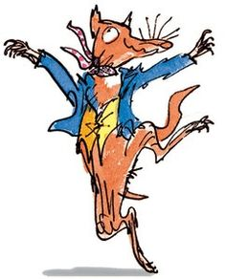
The girl invited everyone to a feast, even the birds if they behaved! “A toast to Mr Cat. Well done!” said everyone.
Mr Fox said, “You are just like me!”

THE END

