**Slaley First School**

Upcoming Events –

Please note, our Coffee and Mince Pie Morning will now take place on 10th December as

unfortunately, our original date was the same date as the Slaley Show.

Attendance

This week’s Attendance

EYFS – 100%

Class 1 – 100%

Class 2 97.5%

Well done EYFS and Class One who are our joint Attendance Cup winners this week!

**Christmas Wreath making Event in the Commemoration Hall**

7.30pm

Wednesday 15th December

Little Reminders …

**PE Kit**

Dear Parents/Carers,

We have had another great week and have thoroughly enjoyed our Children in Need related activities today. We have all taken part in our ‘Pudsey’ laps around the yard and have made Pudsey biscuits in the school hall. We have also created some lovely Pudsey bear collages.

**Supporting the mental health of children**

From next Thursday we have a new initiative starting in school where the children in Class One and Two will be given the

opportunity to access a ‘**Mindfulness Minutes**’ lunch time club. Children who would like to stay in class and access mindful activities will be more than welcome to. The club will run as follows:

Monday (between 12.30pm and 1pm) – **Class 2**

Thursday (between 12.30pm and 1pm) – **Class 1**

We will begin with mindfulness colouring but will progress throughout the weeks to carry out a number of different activities which will support children with their mental wellbeing. I will be adding a new tab to our website which will also have links to websites that support mental health and look forward to developing this over the coming weeks.

Have a lovely weekend everyone, see you all on Monday.

Love from Mrs Hayward

**What is happening in the coming week?**

**Wednesday 23rd November –**

**Bags2school**

**Bags can be dropped off in the tent on our field over the weekend -**

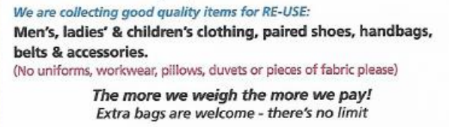

**All bags will be collected by the end of the day.**

This

.

PE Kits

PE Kits (preferably consisting of: yellow t-shirt, blue shorts, blue sweatshirt & jogging bottoms, trainers, spare socks) are required for all pupils to be brought in on a Monday and left in school and taken home on a Friday. All items must be clearly labelled with your child’s name. Uniform can be ordered online from Salto UK Ltd.

Please note, hoodies have been discontinued due to health & safety reasons.

**Friday 19th November 2021**

