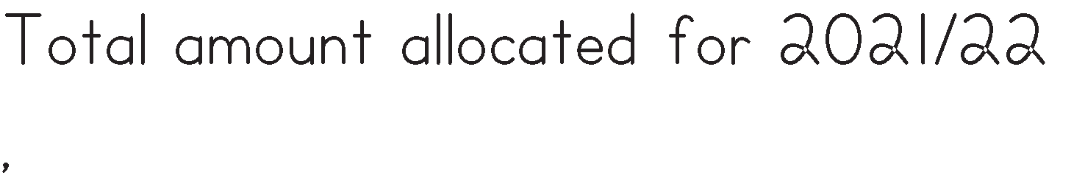

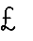
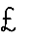

4.24%
£863.88
0.56%

 |  | 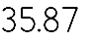
 |  |  |  | 10.68%
 |  | £535 |  | 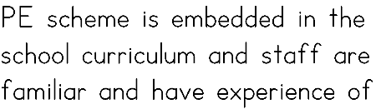

£2,197.81

(£828.81 Staffing)

£1369
Travel
10.71%
£2100
£640

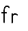
Total £6699.06

C/F -18,891.94

