FOSS Web Update - 4th September 2017
Well it’s been an interesting learning curve for us new FOSS members who took over from long serving members; Laura Macdonald, Linda Johnston and Lucy Irish in October 2016. There’s been lots of baking, raffles, some disco dancing and we’ve learned a lot….’Gluten free’….. What?
Coffee Morning - 30th November 2016 – Raised £16.20
A short but sweet coffee morning just to say hi and introduce ourselves to some of the parents and an opportunity for us really to start to put names to faces. This has been our biggest challenge (well certainly for me and Penny) whose children hadn’t yet started Pre-School and we didn’t really know any other parents.
Christmas Hampers / Posada / Carol Singing – 10th December 2016 – Raised £237
As newbies to the world of creating hampers, we were overwhelmed by the very generous donations received and whilst initially we were worried about receiving enough donations, the school kept re-assuring us that the donations will come in. And they did….enough for 4 brilliant hampers.
Raffle tickets were sold through the school and by Tracey and her team at the Rose and Crown, where the raffle was drawn. The winners were John Wilson who won the 'boozy Santa' hamper, Kevin Doonan (second time lucky) winning the 'little but great' hamper. Helen Savage took home the 'luxury hamper' and Tracey Wetherley (having purchased dozens of tickets) took home the 'pamper hamper'. But the night was also best remembered as a success in another respect with the Posada taking centre stage, surrounded by the Community and a great turnout from the kids of Slaley. It really was a lovely Christmassy atmosphere with both young and old in fine voice as hymns old and new were belted out….Just brilliant.
_{Whatsapp Groups}
In March Naomi Hunter setup a ‘Whatsapp group’ called Slaley Mums. We just appreciated that we don’t all have time at school drop / pickup to have a chat and parent mail can be so formal so it’s been a great way to organise get togethers. We’ve already had a couple of meals out since then. Whilst it was never intended just for mums, the dads have got in on the act and have recently setup their own whatsapp group.
If you're interested, you will need Whatsapp on your phone. For the Slaley mums group, please contact Naomi Hunter on 07841870172 and for the Slaley Dads group contact Mark Foster (on Andreas phone) 07921 079600
Sponsored Walk 25th June 2017 – Raised XXXX
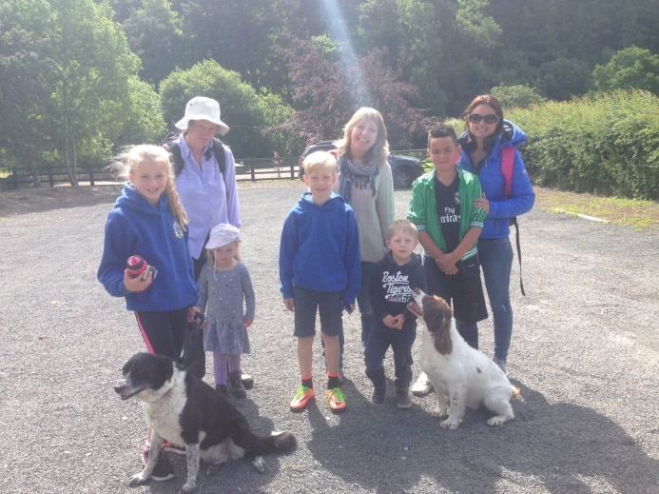
It’s fair to say that we didn’t have a great turnout for the official sponsored walk. It was a lovely sunny day but our walk was driven by Casey and Catherine, both 3 year olds who did well to manage just under 3 miles. Luckily we weren’t sponsored per mile!!
Friday 7th July 2017 – Under 10 Slaley disco – Raised XXXXX
We had a fantastic under 10s Slaley Disco with great feedback. We had a totally unexpected 45 kids rocking up and dancing their socks off (with a few parents joining in too!!). Not sure how he manages it, but the Disco man from Prudhoe entertained the kids for over 2 hours with dancing, games and sweets. This night wasn’t so much about fundraising but getting the kids together and will definitely become a regular on the events calendar.
Thursday 13th July 2017 – School Sports Day – Raised £15.36
With only a slight delay in scheduling due to the 'Slaley weather', we got to see the passion and talent of the kids at the School Sports day and it was great to see such enthusiasm. However there was also some fantastic baking donations too which accompanied teas and coffees nicely, well done.
Friday 20th July 2017 – Summer Fayre – Raised XXXX
With paintballing, games, stalls and food, we raised nearly £400, a fantastic effort. For the new FOSS team, it was the first time we'd organised a Fayre, we've learned a lot and looking forward to building on ideas next year.
Games winners were: Find me Treasure and winners of a mountain of sweets, were Mason, Bella Wilson and Lily Hook. Winner of the guess the number of sweeties was Georgina Beckett.
These events do only take place thanks to kind supporters, contributions and volunteers, so a huge thank you to you all for your continued support. But we’re always looking for volunteers to help out on events and new ideas.
Next FOSS meeting; Tuesday 5th September at 7pm at Slaley First School
_{Agenda}
- Review of previous events. Monies raised, what worked, what didn't, how we can improve.
- _{Review of Financials}
- _{Update on 'Slaley Social’}
- _{AOB}

